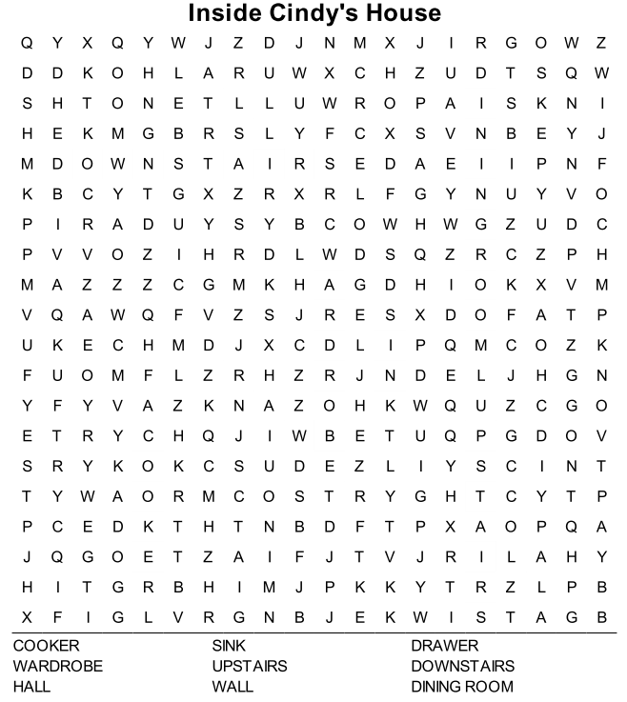
HW (November 17th, Wednesday)
- PB Ex.1 p.12 – revise the words (TEST), wordsearch.
- PB Ex.2 p.12 – read 10 times (YouTube Welcome 2 Unit 2 Lesson 2), write the dialogue with 8 changes (in HW copybook).
- WB Ex.7 p.10 (listening).

